Assignment 2
” Interfaces in Java”

[10 marks in total]
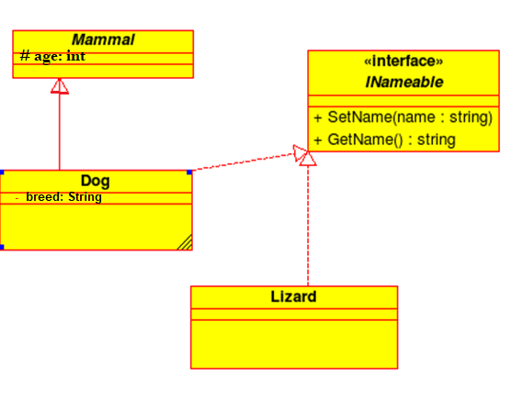
Note: In this UML class hierarchy, a Dog is a Mammal, but a reptile is not a mammal whereas both Dog and Lizard may be nameable (having nickname) and both may have some other properties and functions.
In a addition to the interfaces above, add the following interfaces:
- Comparable interface to Dog class;
- Cloneable interface to Lizard.
- Test it in a TestAnimal class!
- Submit with your reflections on-line.

- [7 marks] Java implementation: Implement all required classes in Java, according to simplified UML class diagram. You may add some other properties and methods, but you can’t modify none of the current.
a Start your project with package name: package groupnumber, for example group2 – in test class (class that contain main method), on the to add the full name and the ID of the group members

b Implement all required classes from your diagram. Create a test class with at all types of object and demonstrate how to use polymorphism and different interfaces. You are expected to add all programming comments in your code (JavaDoc is preferable). Lastly, you have design a UML class and object diagram. Save pictures for your object diagram for further submission.
- [3 marks] Reflections document – in PDF or DOC format.
Prepare a separate document to reflect on how you have completed Assignment. Reflection is nothing but your personal commentary on your own contribution and coding habits.
  - Add a picture of your UML class diagram (from [1]), and UML object diagram (from [1]), with a brief description.
  - Add how the essential classes, methods, parameters, or entire programs were designed and handled while implementing the project. Add how polymorphism was implemented in the project, and different interfaces;
  - Add screen shots from your final demo (project run), copied from the console “as is”, with a brief description
  - Add your reflection assignment notes to include some of the following:
- Significant types of errors/warnings you faced when coding programs
- Whether you were able to correct these errors/warnings quickly
- What debugging strategy you used, e.g., searched the Web for a solution, contacted tutor, solved by self, used a debugging tool, talked to a friend, . . .
- What commenting strategy you used, eg., Javadoc or inline commenting of key methods and variables, . . .
- What testing strategy you used, eg., tested for typical inputs, extensively tested the code, . . .
- What code optimization techniques you followed, if any (e.g., unused local variables, parameters, and private methods; wasteful string usage; unnecessary if statements and for loops that could be while loops; duplicate code; etc. .
- Resources that you referred to (online resources, book references, etc)
- Other comments that reflect on the process of your personal learning to program. As you can see, the reflection component is quite fluid and personal.

